PROJECT DESIGN PHASE – II CUSTOMER JOURNEY MAP

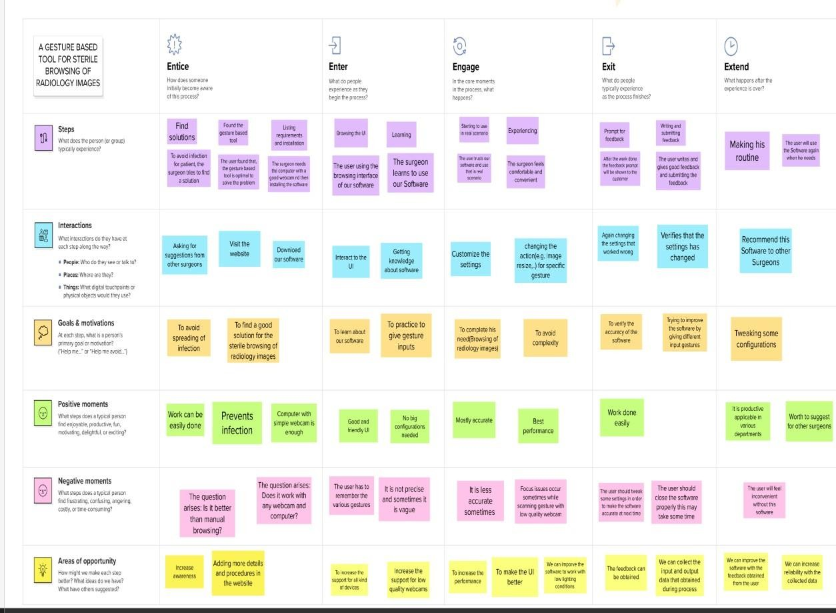

|  |  |
| --- | --- |
| DATE | 05 OCTOBER 2022 |
| TEAM ID | PNT2022TMID16374 |
| PROJECT NAME | A GESTURE BASED TOOL FOR STERILE BROWSING OF RADIOLOGY IMAGES |
| MAXIMUM MARKS | 4 MARKS |